**CMSC203 Assignment 2 Implementation (Documentation)**

Class: CMSC203 CRN XXXX

 Program: Assignment #2

Instructor:

 Summary of Description: (This assignment is random number guessing game. This game create a random number between 0 and 99 and ask the user to guess the number. )

 Due Date: 02/23/2022

 Integrity Pledge: I pledge that I have completed the programming assignment independently.

 I have not copied the code from a student or any source.

**Part1: Pseudo Code:** Here is a pseudo code for Assignment 2 program:

Generate a random number

Ask for first guess

If it’s low or high tell the user to enter number in between

Ask for the second guess

Cheek again if it’s low or high tell the user to enter number in between

Repeat this until user enters the 7th guess or until the user enter the correct answer.

Ask the user if they want to use it again

If not exit the program and display the programmer name

**Part2: Comprehensive Test Plan**

A good test plan should be comprehensive. This means you should have a few test cases that test when the input is in and out of range, division by 0, incorrect Data type, etc. (Provide valid and invalid input)

|  |  |  |  |  |
| --- | --- | --- | --- | --- |
| Cases | Input | Expected Output | Actual Output | Did Test Pass? |
| Case 1  91 | 10  90  95  93  91 | Too low  Too low  Too high  Too high  correct | Enter your first guess  10  Number of guesses is 2  Your guess is to low  >>> Guess must be between 10 and 100. Try again  90  Number of guesses is 3  Your guess is to low  >>> Guess must be between 90 and 100. Try again  95  Number of guesses is 4  Your guess is to high  >>> Guess must be between 90 and 95. Try again  93  Number of guesses is 5  Your guess is to high  >>> Guess must be between 90 and 93. Try again  91  Number of guesses is 6  Congratulations, You guessed correctly | yes |
| Case 2  60  13 | 10  90  60  Yes  10  90  13 | Too low  Too high  Correct  Too low  Too low  correct | Enter your first guess  10  60  Number of guesses is 2  Your guess is to low  >>> Guess must be between 10 and 100. Try again  90  60  Number of guesses is 3  Your guess is to high  >>> Guess must be between 10 and 90. Try again  60  Number of guesses is 4  Congratulations, You guessed correctly  Try again? (yes or no)  yes  Enter your first guess  10  18  Number of guesses is 2  Your guess is to low  >>> Guess must be between 10 and 100. Try again  90  18  Number of guesses is 3  Your guess is to high  >>> Guess must be between 10 and 90. Try again  18  Number of guesses is 4  Congratulations, You guessed correctly | yes |
| Case 3  36 | 10  90  36 | Too low  Too high  correct | Enter your first guess  10  Number of guesses is 2  Your guess is to low  >>> Guess must be between 10 and 100. Try again  90 | yes |
| Case 4  75 | 10  75 | Too low  correct | Enter your first guess  10  75  Number of guesses is 1  Your guess is to low  >>> Guess must be between 10 and 100. Try again  75  Number of guesses is 2  Congratulations, You guessed correctly  Try again? (yes or no) | yes |

**Part3: Screenshots related to the Test Plan:**

**Case 1**

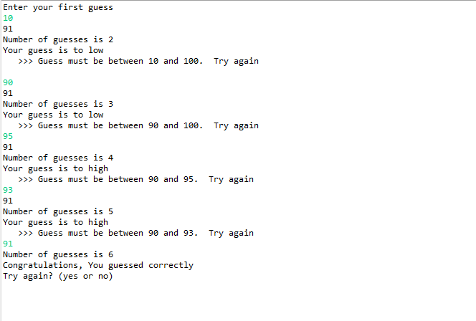

**Case 2**

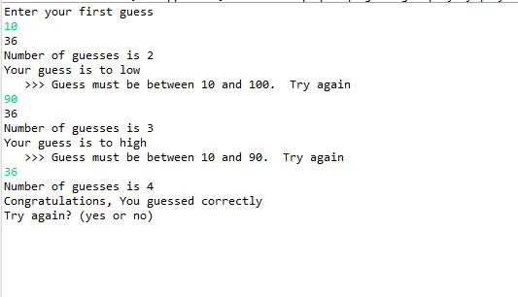

**Case 3**

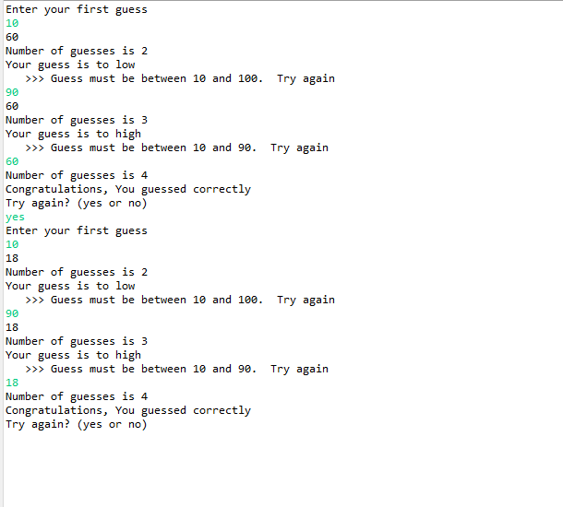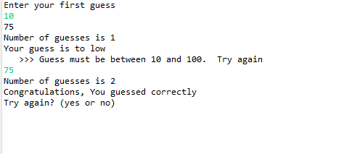

**Case 4**



**Lessons Learned** <Provide answers to the questions listed above>**:**

Write about your Learning Experience, highlighting your lessons learned and learning experience from working on this project.

What have you learned?

What did you struggle with?

What would you do differently on your next project?

What parts of this assignment were you successful with, and what parts (if any) were you not successful with?

Provide any additional resources/links/videos you used to while working on this assignment/project.

**I learned in this Assignment to use different methods and constructors. And also I learned to use parameters and how private variables work private methods work and how public methods work. When returning something how the methods be address differently. I can’t say I struggle with anything if I have to say if I had trouble remembering is that when returning something there methods write differently.**

**In the next Assignment I would first go through each method and understand their types. I can say I got success with everything in the project.**

**Check List:** <Provide answers to the column Y/N or N/A >**:**

|  |  |  |  |
| --- | --- | --- | --- |
| **#** |  | **Y/N** | **Comments** |
|  | **Assignment files:** |  |  |
|  | * FirstInitialLastName_ Assignment#_Moss.zip | **Yes or No** | **Y** |
|  | * FirstInitialLastName_Assignment#.docx/.pdf | **Yes or No** | **Y** |
|  | * Source java files | **Yes or No** | **Y** |
|  | **Program compiles** | **Yes or No** | **Y** |
|  | **Program runs with desired outputs related to a Test Plan** | **Yes or No** | **Y** |
|  | **Documentation file:** |  |  |
|  | * Comprehensive Test Plan | **Yes or No** | **Y** |
|  | * Screenshots related to the Test Plan | **Yes or No** | **Y** |
|  | * Screenshots of your GitHub account with submitted Assignment# (if required) | **Yes or No or N/A** | **Y** |
|  | * UML Diagram (if required) | **Yes or No or N/A** | **Y** |
|  | * Algorithms/Pseudocode (if required) | **Yes or No or N/A** | **Y** |
|  | * Flowchart (if required) | **Yes or No or N/A** | **N/A** |
|  | * Lessons Learned | **Yes or No** | **Y** |
|  | * Checklist is completed and included in the Documentation | **Yes or No** | Y |